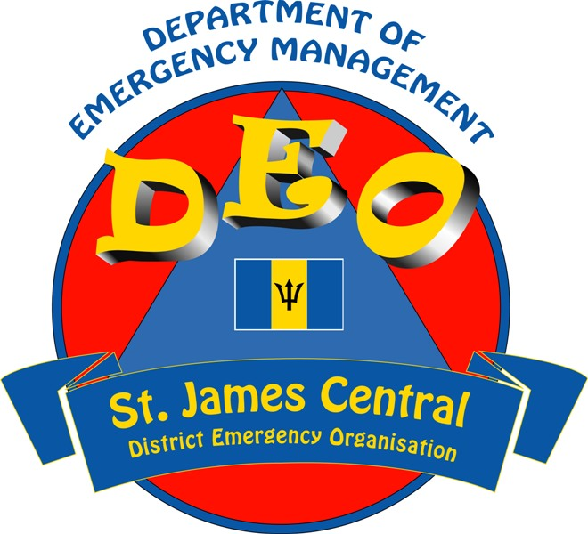
DEPARTMENT OF EMERGENCY MANAGEMENT
ST.JAMES CENTRAL DISTRICT EMERGENCY ORGANISATION
MEMBERSHIP REGISTRATION FORM

Name:………………………………………………………………………………..……. Date of Birth……………………………………

Address:…………………………………………………………………………………………………………………………………………………….

Contact Numbers (H)……………………………………. (W)…………………………………………..(C)………………………..…………

Email:…………………………………………………………………………………………………………………………………………………………

Skills/Equipment/Tools which I can make available to the DEO…………………………………………………………………

………………………………………………………………………………………………………………………………………………………………….

…………………………………………………………………………………………………………………………………………………………………

Areas in which I need training……………………………………………………………………………………………………………………

I may be assigned to the following sub-committees (please tick two)

Damage Assessment & Needs Analysis Care of the elderly/disabled/vulnerable

Road Clearance & Tree Trimming Shelter & Food Service
Medical Assistance Finance
Communication Special Projects / Training
I can be available BEFORE AFTER an impact.
St. James Central D.E.O. is part of the voluntary mechanism of the Department of Emergency Management, seeking to offer our community and the island the best approaches and practices in comprehensive disaster management, involving all phases of the disaster management cycle: mitigation, preparedness, response and recovery.

Signed …………………………………………………………… Date ………………………………………………….

